### PUBLIC HEALTH AWARENESS CAMPAIGN ANALYSIS

#### Overview Of Our Work:

* The purpose of this research is to discuss the expansive reach a public health campaign can have. Accordingly, we developed a multidimensional analysis framework considering three areas: communication, education, and epidemiological surveillance.

## Public Health Awareness Campaigns Typically Include The Following:

* Campaign goals and objectives: What do you hope to achieve with your campaign? What specific changes in knowledge, attitudes, or behaviors do you want to see in your target audience?
* Target audience: Who are you trying to reach with your campaign? What are their needs, interests, and concerns?
* Campaign messages: What key messages do you want to communicate to your target audience? How will you frame your messages in a way that is relevant and persuasive?
* Campaign strategies and activities: How will you reach your target audience and deliver your messages? What types of activities will you use?
* Evaluation plan: How will you measure the success of your campaign? What indicators will you use to track progress towards your goals and objectives?

## **In Addition To These Core Elements, Public Health Awareness Campaigns May Also Include The Following:**

* Background information on the health issue: This information can help to provide context for your campaign and explain why it is important.
* Literature review: This section can summarize the existing research on the effectiveness of different public health awareness campaign strategies.
* Budget: This section should detail the estimated costs of your campaign.
* Timeline: This section should outline the key milestones and deadlines for your campaign.

## Here Are A Examples Of Project Documents For Public Health Awareness Campaigns:

* Campaign plan for a national campaign to promote flu vaccination
* Project proposal for a community-based campaign to reduce smoking among pregnant women
* Evaluation report for a campaign to raise awareness about HIV/AIDS

## A Protocol For Designing Data Analytic For Public Health Care Awareness Should Include The Following Steps:

1. Identify the public health issue: What public health issue are you trying to raise awareness about? What are the key messages that you want to communicate?
2. Identify your target audience: Who are you trying to reach with your public health awareness campaign? What are their needs, interests, and concerns?
3. Collect data: What data do you need to collect to support your public health awareness campaign? This data could come from a variety of sources, such as surveys, interviews, focus groups, social media, and government databases.
4. Clean and prepare the data: Once you have collected your data, you need to clean it and prepare it for analysis. This may involve removing duplicate records, correcting errors, and converting the data into a format that is compatible with your data analytics software.
5. Analyze the data: Use data analytics software to analyze your data and identify trends, patterns, and relationships. This information can then be used to develop more effective and targeted public health awareness messages.
6. Visualize the data: Visualizing the data can help to make it more accessible and understandable to your target audience. You can use a variety of data visualization tools, such as charts, graphs, and maps, to present your findings.
7. Communicate the results: Once you have analyzed and visualized your data, you need to communicate the results to your target audience. This can be done through a variety of channels, such as social media, blog posts, infographics, and presentations.

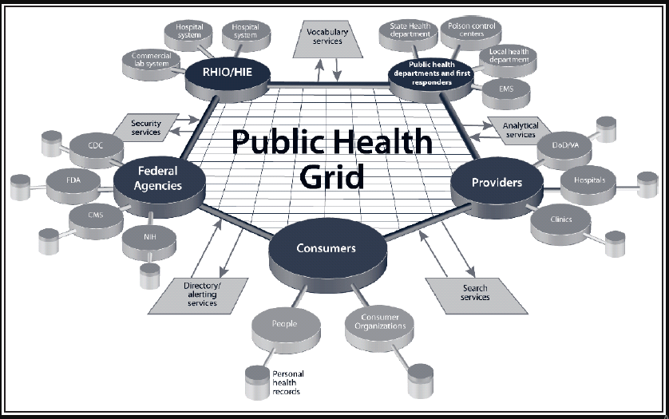

#### Conclusion:

* Public health awareness campaigns can be an effective way to improve public health, but it is important to remember that they are most effective when they are part of a comprehensive approach to public health. This approach should also include other interventions, such as policy changes, environmental changes, and access to healthcare services.Public health awareness campaigns are designed to educate the public about important health issues and promote healthy behaviors. They can be effective in improving public health, but it is important to carefully design and implement them.